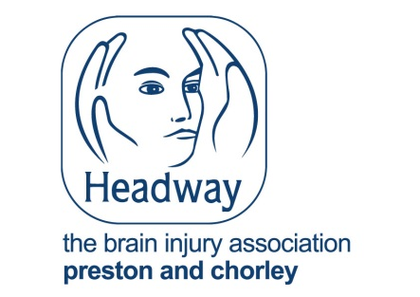

Application Form

Headway Outreach Patient Liaison Worker
18 hrs per week Fixed Term contract for 12 months.

This form must be returned by 5.00pm on 18th May 2026

Completed applications should be returned to:

Hard copies: Electronic copy (FAO Liz Bamber):

Headway Central Lancashire liz@headwaycentrallancashire.org.uk
Heartbeat Centre
Preston North End
Sir Tom Finney Way
Preston
PR1 6PA

Guidance notes for completion of application forms:

Applicants are advised that candidates will only be short-listed based on the information provided in their application form.

Headway Central Lancashire reserves the right to shortlist only those candidates who best match the criteria.

Interview dates to be arranged.

All sections of the application form must be completed.

Title | Surname | Forename(s)
Address: | Contact Number: | Email address:

Referees
References will only be contacted with your permission and after interview.

1] NAME
JOB TITLE
Company/organisation
Address

Postcode
Telephone
Email
2] NAME
JOB TITLE
Company/organisation
Address

Postcode
Telephone
Email
Career History

Please outline your career to date beginning with the most recent:

Employer name and nature of organisation | Post held and brief outline of responsibilities | Dates  (month and year)  From To | Reason for leaving
Notice required if applicable:

Qualifications and training:

From | To | Type of school/college/university attended | Subject and grade/result

Are you a member of professional institutions/associations:
Demonstrate how your qualifications and or experience satisfy the key criteria for the post which will be used to shortlist. Please refer to the Person Specification and give examples to illustrate your achievements.

Please outline any voluntary or community work that you have undertaken.

ESSENTIAL Do you hold a current full driving licence?

Do you have access to a form of transport which will permit you to meet the requirements of the post in full?

Have you ever been convicted of a criminal offence which is not a spent conviction under the Rehabilitation of Offenders (Exemptions) (NI) Order 1979? If so please give details of the conviction and the sentence.

Do you have any prosecutions pending? (if yes please give details)
Details:

Declaration and signature

Any candidate found to have provided false or inaccurate information may be liable to disqualification or, dismissal. I declare that the information provided is complete and accurate.
I understand that if I am successful in my application, I will be required to complete an Enhanced Access NI Disclosure Certificate Application Form.
I declare that the particulars given are to the best of my knowledge complete and accurate.

Signature

Please email your completed form to liz@headwaycentrallancashire.org.uk

