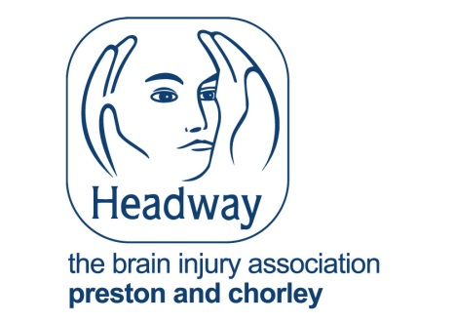

**Headway Lottery Joining Form**

For only £1.00 per week you get 10 chances in the Headway Lottery, so 10 chances every week to win £1,000 cash and other cash prizes. And your membership will help Headway support people affected by acquired brain injury in Preston & Chorley.

**How to join**

Complete the following form, choosing how many entries you would like and how you’d like to pay. You can pay by Direct Debit, credit/debit card, cash or cheque.

**What will happen next?**

We will process your form and send you confirmation of your membership and lucky Headway Lottery numbers. If you chose to pay by Direct Debit we will also confirm the date of your first Direct Debit, the amount and frequency of payment. You will receive this letter at least 3 working days before any payment is taken from your bank account.

**The draw**

The Lottery takes place every Friday and you will have the chance of winning our £1,000 weekly jackpot or one of our many cash prizes. There is no need to claim your prize as the winners cheques are posted out automatically. Winning numbers can also be found on our website: ww.headwayprestonandchorlewy.org.uk/lottery/

If you have any queries, please contact the Lottery team on 01772 717147.

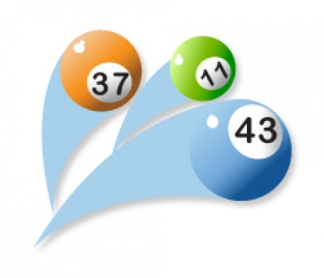

**Good luck & thanks for your support!**

The Heartbeat Lottery is licensed and regulated by the Gambling Commission, [www.gamblingcommission.gov.uk](http://www.gamblingcommission.gov.uk). Licence Number:000 005098-N030907 011 Promoter: Heartbeat. Players must be over 16 years of age to enter the Heartbeat Lottery. Please pay responsibly. If you are concerned about playing too much telephone Gamble Aware on 0808 8020 133 or visit www.gambleaware.co.uk

**Headway Lottery Joining Form** 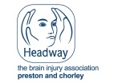

Please fill in the form below carefully and send the entire form to: Headway, Heartbeat Centre, Sir Tom Finney Way, Preston, PR1 6PA

**Complete your details**

Title:…………………………..First Name:………………………………………Surname:………………………………………………..

Address:…………………………………………………………………………………………………………………………………………………………………………………………………………………………………………………………………………………………………………………

Postcode:……………………………………………………………………………………………………………………………………………...

Telephone:………………………………………………. Email:…………………………………………………………………..

Signature: Date:

*(I am 16*

*years or over)*

We’d love to keep in touch with you about our work with people with acquired brain injury, and how your support can make a real difference. We may use the details provided to contact you from time to time, by email, phone, post or text. If you prefer not to hear from us please tick this box.

**Select your entry options**

|  |  |  |  |
| --- | --- | --- | --- |
| **Every** **4** **weeks**  1 entry per week = £4.00  2 entries per week = £8.00 | **Pay** **Quarterly**  1 entry per week = £13.00  2 entries per week = £26.00 | **Pay** **Half** **Yearly**  1 entry per week = £26.00  2 entries per week = £52.00 | **Pay** **Annually**  1 entry per week = £52.00  2 entries per week = £104.00 |

**Pay by Direct Debit**

**Instruction to your Bank or**

**Pay by credit/debit card**

Please debit the amount as indicated above, starting immediately until further notice, from my card:





  

**Pay by cheque/postal order/cash (we will contact you about this).**

I enclose a cheque/postal order for the total of



*Please make cheques payable Heartbeat (our administrators)*

**Return your completed form to:**

Headway, Heartbeat, Sir Tom Finney Way, Preston, PR1 6PA



**Building Society to pay by Direct Debit**

 

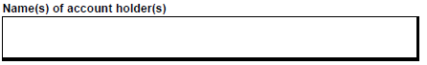

**Name and full address of your Bank or Building Society**

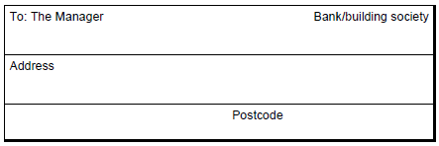

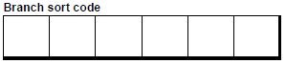

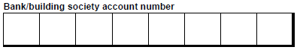

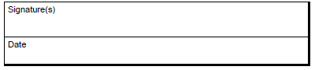

Instructions to your Bank or Building Society: Please pay Headways Direct Debits from the account detailed in this instruction, subject to the safeguards assured by the Direct Debit Guarantee. I understand that this instruction may remain with Heartbeat and, if so, details will be passed electronically to my Bank or Building Society. Banks and Building Societies may not accept Direct Debit instructions from some types of account.

Heartbeat, Sir Tom Finney Way, Preston, PR1 6PA, registered charity number: 1168850.